

**YEAR: 10**

**2017**

**SUBJECT: Science**

**TEST: Genetics**

**TIME: 60 minutes**

**QUESTIONS: 20 Multiple Choice (20 marks)**

**4 Short Answer (24 marks)**

**1 Extended Answer (10 marks)**

**TOTAL MARKS: 54 marks**

**DO NOT WRITE ON OR MARK THIS PAPER**

**SECTION ONE - MULTIPLE CHOICE** [Total 20 marks]

This section has **twenty (20)** questions. Answer **all** questions on the separate Multi-Choice Answer Sheet provided. ______________________________________________________________________________

1. Recall the number of chromosomes contained in each human egg or sperm.
2. 23 chromosomes

1. 46 chromosomes

1. 3 pairs of chromosomes

1. a diploid number of chromosomes
2. The structure of DNA may be described as a twisted ladder. Recall what forms the upright parts of the ladder.
3. alternating sugar and phosphate units
4. nitrogen bases

1. amino acids

1. proteins
2. Recall the number of chromosomes in cells after meiosis, compared to the original cell.
3. Double
4. Same
5. Half
6. Quarter
7. Chromosomes are found in the nucleus of
8. most cells of your body
9. brain cells only
10. reproductive cells only
11. stem cells that have not yet differentiated
12. The sex of an individual is determined when the
13. egg is formed
14. sperm is formed
15. egg is fertilised by the sperm
16. embryo is 12 weeks old
17. The gametes of a fruit fly have four chromosomes. What is the diploid number for the fruit fly?
18. 2
19. 4
20. 6
21. 8
22. In a certain organism's DNA, 10% of the bases are thymine. Calculate the percentage of bases that would be guanine.
23. 10%
24. 40%
25. 80%
26. 90%

8. The figure below shows one half of a homologous pair of chromosomes. Identify the other homologous chromosome.

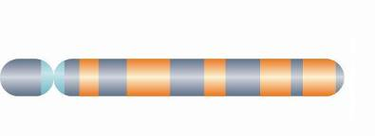

1. 
2. 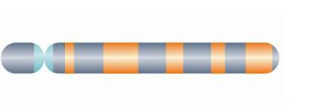
3. 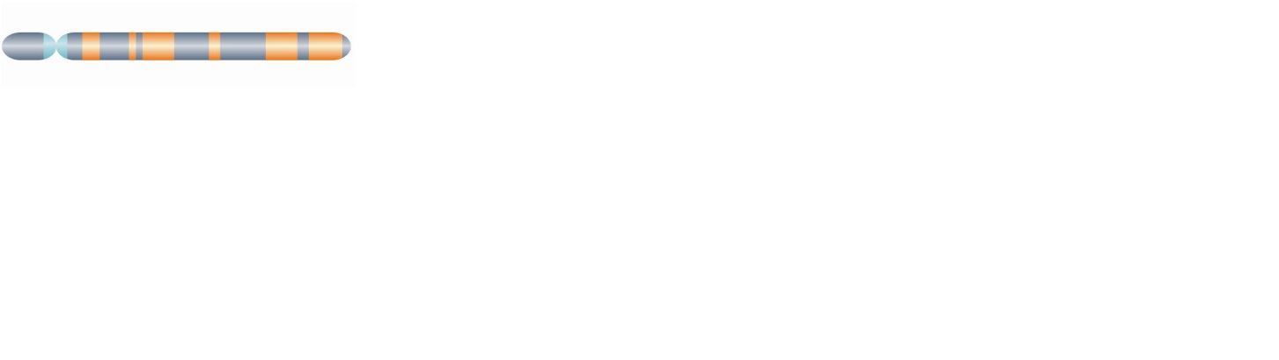
4. 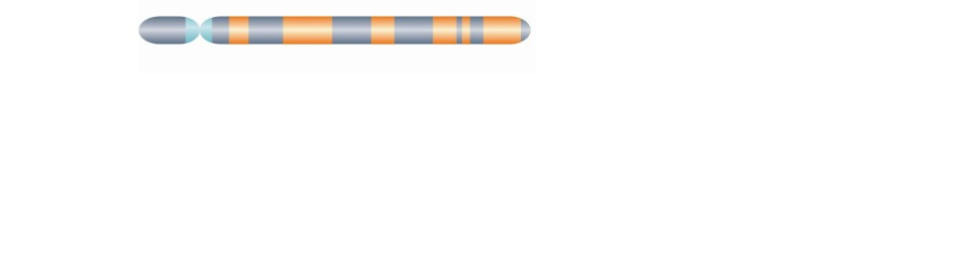
5. What is the name for one or more forms of the same gene?
6. Chromosome
7. Codon
8. Allele
9. Chromatid

10. Meiosis is also referred to as 'reduction division' because it produces daughter cells containing the haploid number of chromosomes. Where would meiosis typically occur?

In the

1. division of skin cells
2. production of gametes
3. replication of red blood cells
4. replacement of damaged muscle cells

11. The lack of skin and hair pigments is known as albinism and is a recessive characteristic. If two parents had normal pigmentation and they produced an albino child, it would be reasonable to conclude that their next child would have a

1. 25% chance of being an albino
2. 50% chance of being an albino
3. 75% chance of being an albino
4. no chance of being an albino

12. A biology student wants to examine gamete formation. Which of the following prepared slides would be the most suitable for her to examine?

1. Human skin
2. Rat testes
3. Early developing embryo
4. Human bone marrow

13. Assuming that the only colours for human eyes are blue and brown, and that brown is dominant to blue, then

1. blue eyes children must have blue eyed parents
2. if one parent has blue eyes and the other one has brown eyes, all the children must have brown eyes
3. if both parents have brown eyes the children must have brown eyes
4. blue eyed parents must have blue eyed children

14. Which of the following best describes what occurs during **metaphase**?

1. Chromosomes line up in a single line across the centre of the cell
2. Chromosomes become visible and the nuclear membrane disappears
3. Each pair of chromatids separate at the centromere
4. Cytoplasm divides down the middle of the cell

15. Which of the following statements about mutations is FALSE?

1. Mutations can occur in any cell that contains DNA
2. Mutations can be inherited
3. Any change in a DNA sequence is called a mutation
4. A mutation always has a damaging effect on cells

16. Half a strand of DNA bases is shown below. Identify the complimentary DNA strand.

ACG TCA ATG CATG

1. TGC AGT CAC CTAG
2. TCC AGT TAC GTAA
3. TGC AGT TAC GTAC
4. TGC AGA TAC TTAC

17. In which phase do cells spend most of their time?

1. Anaphase
2. Metaphase
3. Interphase
4. telophase

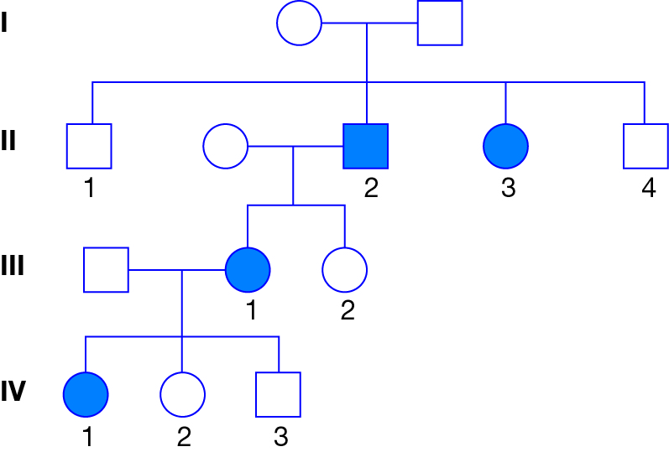The following pedigree relates to **questions 18-20**.

The pedigree above shows the inheritance of a disease (shaded) caused by a recessive gene 'g'. Those with the dominant gene 'G' do not show the disease.

18. Identify the genotypes of the following individuals, in order:

Generation II number 3; Generation III male; Generation IV number 2.

1. Gg, gg, Gg
2. gg, Gg, Gg
3. Gg, Gg, Gg
4. gg, gg, Gg

19. Locate the individual in Generation IV number 1. What would they call the individual in Generation II number 2?

1. Grandmother
2. Grandfather
3. Uncle
4. great uncle

20. The disease is autosomal (not sex linked). How many individuals are heterozygous?

1. 5
2. 7
3. 9
4. it's not possible to tell from the data provided



**TEST: Genetics**

**ANSWER BOOKLET**

**NAME:**

**FORM:** **DATE:**

Multiple Choice Short Answer Extended Answer Total

**/ 24**

**/35**

**/ 20**

**/20**

**/ 10**

**/10**

**/ 54**

**/10**

**SECTION ONE:** Multiple choice answers

Cross (X) through the correct answer.

|  |  |  |  |  |  |  |  |  |  |  |
| --- | --- | --- | --- | --- | --- | --- | --- | --- | --- | --- |
| **1** | a | b | c | d |  | **11** | a | b | c | d |
| **2** | a | b | c | d |  | **12** | a | b | c | d |
| **3** | a | b | c | d |  | **13** | a | b | c | d |
| **4** | a | b | c | d |  | **14** | a | b | c | d |
| **5** | a | b | c | d |  | **15** | a | b | c | d |
| **6** | a | b | c | d |  | **16** | a | b | c | d |
| **7** | a | b | c | d |  | **17** | a | b | c | d |
| **8** | a | b | c | d |  | **18** | a | b | c | d |
| **9** | a | b | c | d |  | **19** | a | b | c | d |
| **10** | a | b | c | d |  | **20** | a | b | c | d |

**SECTION TWO - SHORT ANSWER** [Total 24 marks]

This section has **four (4)** questions. Answer **all** questions. Write your answers in the spaces provided. ______________________________________________________________________________

**Question 21**

DNA is the genetic material that is passed on from one generation to another.

1. What does the acronym DNA stand for? (1 mark)

______________________________________________________________________________

1. Name the complementary base pair for the following nitrogen bases:

Adenine _____________________________ (1 mark)

Guanine _____________________________ (1 mark)

Explain the differences between each pair of terms.

c) genotype and phenotype (2 marks)

________________________________________________________________________________________________________________________________________________________________________________________________________________________________________________________________________________________________________________________

d) heterozygous and homozygous (2 marks)

______________________________________________________________________________________________________________________________________________________________________________________________________________________________________________________________________________________________________________________________________________________________________________________________________

**Question 22**

a) Peas can be tall or dwarf. If tall (T) is dominant over dwarf (t), predict the phenotype and genotype ratios of the F1 generation, when a set of dwarf peas are crossed with heterozygous tall peas. (3.5 marks)

|  |  |
| --- | --- |
|  |  |
|  |  |  |
|  |  |  |

Genotype ratios: ________________________________________________________________

Phenotype ratios: _______________________________________________________________

b) Mary has black hair like her father, but her mother has red hair. Mary is pregnant to Bill, who has red hair. What is the probability that their child will have red hair? Assume hair colour is determined by a pair of genes at one locus, and that black hair is dominant to red.

(2.5 marks)

|  |  |
| --- | --- |
|  |  |
|  |  |  |
|  |  |  |

Probability of child having red hair (%): ___________________________________________

**Question 23**

The diagram below shows a simplified illustration of the stages of mitosis. However, the stages are not in the correct order. Write the letters that correspond to each stage (a, b, c, d, e), in the correct order on the line below.



(5 marks)

______________________________________________________________________________

**Question 24**

Haemophilia is an X-linked recessive disease. The symbol XH is used to show the normal gene on the X chromosome, and the symbol Xh is used to show the recessive gene on the X chromosome.

a) State the possible genotype/s of a

1. Haemophilic male (1 mark)

______________________________________________________________________________

1. Non-haemophilic male (1 mark)

______________________________________________________________________________

1. Non-haemophilic female (1 mark)

______________________________________________________________________________

b) A female may be a 'carrier' of the disease. Define the term 'carrier' and state the genotype a female 'carrier' of haemophilia would display. (3 marks)

______________________________________________________________________________________________________________________________________________________________________________________________________________________________________________________________________________________________________________________________________________________________________________________________________

**SECTION THREE - EXTENDED ANSWER** [Total 10 marks]

This section has **one (1)** question. Complete your answer in the space below. ______________________________________________________________________________

**Question 27** (10 marks)

Draw up a table to explain the similarities and differences between MITOSIS and MEIOSIS.

__________________________________________________________________________________________________________________________________________________________________________________________________________________________________________________________________________________________________________________________________________________________________________________________________________________________________________________________________________________________________________________________________________________________________________________________________________________________________________________________________________________________________________________________________________________________________________________________________________________________________________________________________________________________________________________________________________________________________________________________________________________________________________________________________________________________________________________________________________________________________________________________________________________________________________________________________________________________________________________________________________________________________________________________________________________________________________________________________________________________________________________________________________________________________________________________________________________________________________________________________________________________________________________________________________________________________________________________________________________________________________________________________END OF TEST